Isothermal DNA folding for origami based plasmonic nanostructures

Andreas Kopielski, Anne Schneider, Matthias Thiele, Andrea Csáki, Wolfgang Fritzsche

Leibniz Institute of Photonic Technology, Albert-Einstein-Straße 9, 07745 Jena, Germany

DNA origami technique is a powerful tool for the precise positioning of plasmonic nanostructures in the range of a few nanometers. DNA-nanoparticle structures are usually produced in two steps divided in the folding of the DNA origami and a subsequent conjugation with functionalized nanoparticles. A simultaneous assembly could not only increase the yield but also allows the realization of more complex plasmonic constructs, especially for a three dimensional shape. Such a one-pot solution demands an optimization of the folding protocols.
Our investigations of the DNA folding process without denaturing conditions are also discussed like a self-assembly of DNA origami even at room temperature. This would be also promising for a one-pot folding of DNA and thermo-sensitive biomolecules like enzymes.

For DNA-nanoparticle structures, we present a method where the nanoparticles are functionalized with staple strands directly involved in the folding process and therefore supported the one-pot self-assembly of DNA-nanoparticle structure.

The DNA surface can work as a nanobreadbord for spherical or anisotropic nanoparticles like silver nano-prisms. Latter ones are highly interesting because of their plasmonic properties but are challenging in their stability. Here the silver nano-prisms were covered with a very thin gold layer and conjugated with DNA to solve this problem.

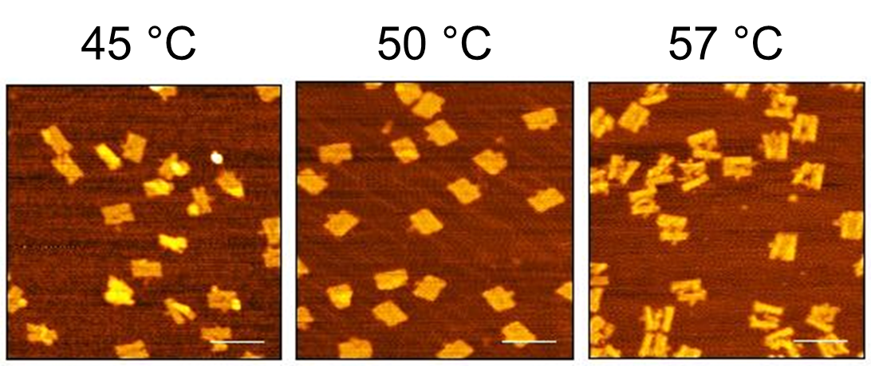 | 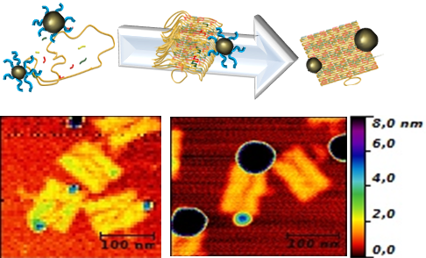 | 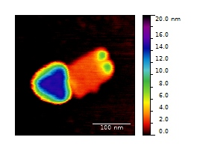
Fig. 1 | Fig. 2 | Fig. 3

Fig. 1: Folding of DNA rectangles at constant temperature without a prior denaturation
Fig. 2: self-assembly of DNA-nanoparticles structures in a one-pot solution
Fig. 3: gold coated silver nano-prism and 5 nm gold nanoparticles

[1] P.W. Rothemund (2006). Nature, 440 (7082), 297–302.
[2] Ding et al.(2010). J Am Chem Soc, 132, 3248-3249

